**A step by step guide to using JDBC with Eclipse Step 1:**

**Create an Eclipse Project**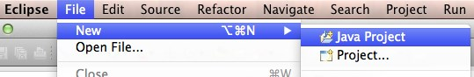

A project in Eclipse is essentially a folder containing all the source code and other ﬁles you need to build your program. Let’s start by creating a project for your program.

1. Open Eclipse

2. From the File menu select New →Java Project

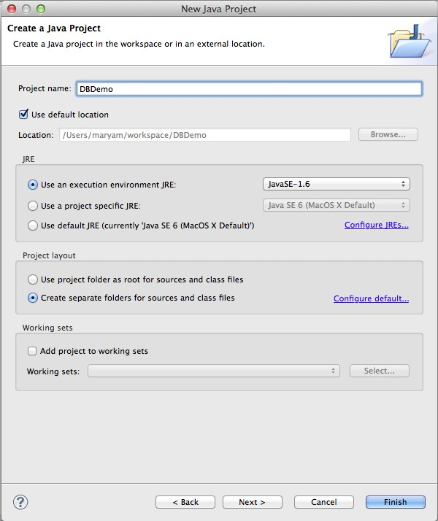3. Give your project a name, like “DBDemo.” You can use the default values for all the other settings. Make note of the project folder in the “Location” box; you will need to remember this later.

4. Press Finish to create the project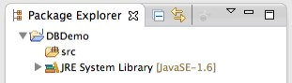

5. Eclipse might ask you whether you want to switch to the Java perspective. If so, say Yes. 6. You should see an empty project which looks something like this.

**Step 2: Install the Connector/J JDBC driver**

In this step, we install the Connector/J driver so our program can connect to MySQL.

1. Go to this web page: <http://www.mysql.com/downloads/connector/j/>

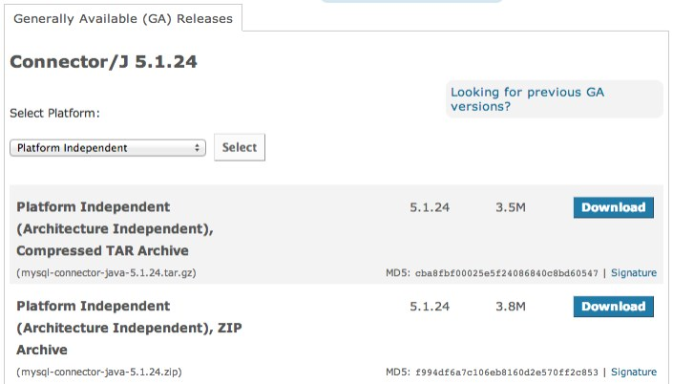2. Press the download button next to the “Platform Independent (Architecture Independent), ZIPAr-chive” version. (Or the TAR version if you prefer; it doesn’t really matter.)

3. The next page will ask you to create an account. Instead, click the little blue link on the bottom that says “No thanks, just start my download.”

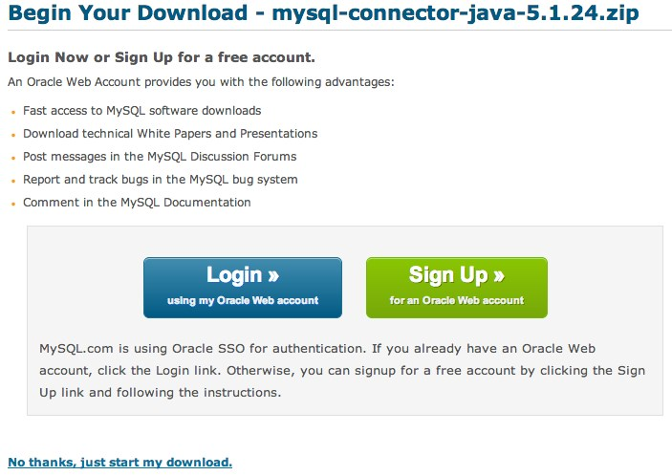

4. Open the .zip ﬁle you just downloaded, and look for a ﬁle inside named

mysql-connector-java-5.1.24-bin.jar. Copy this ﬁle into your project directory (from the Location box in step 3 of the last section).

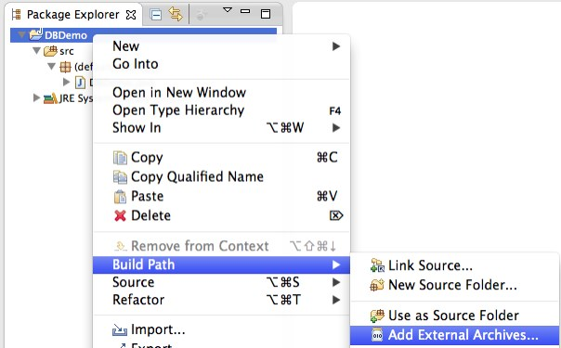5. Now that we have the driver, we need to tell your project about it. Go back to Eclipse, right click on the project, and select Build Path →Add External Archives...

6. Select mysql-connector-java.5.1.24-bin.jar and press Open

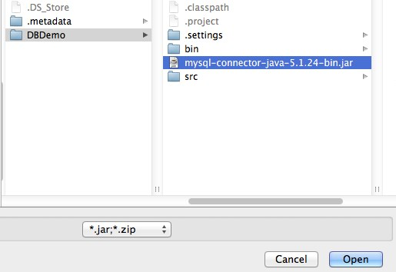

7. Now we’re ready to conﬁgure the project for your copy of MySQL and run it!

**Step 3: Set up a simple database program**

We have the program, we have the driver, and we just need a few ﬁnal touches before we’re ready to go.

1. create MySQLConnectDemo.java and open the ﬁle.

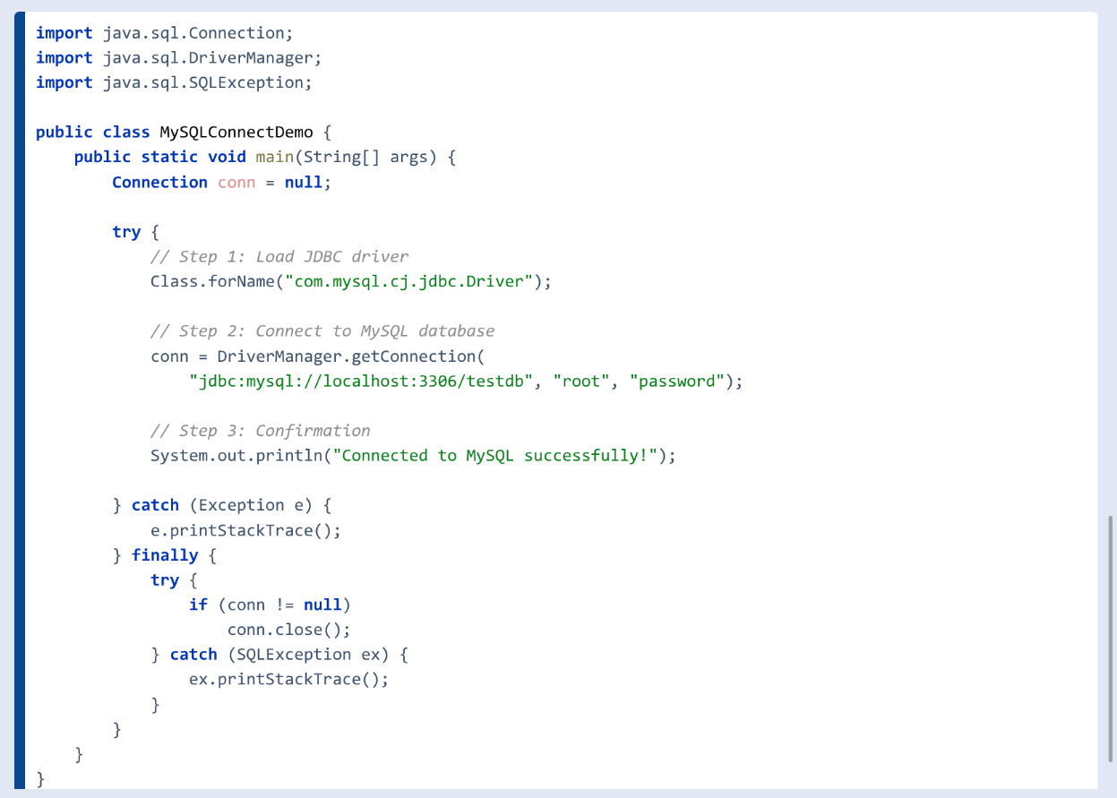

1. Click on the run button. and see the message in console.